THE URINARY SYSTEM
https://youtu.be/I8cfNdVRkO0
- Choose the correct answer:
- Oliguria, hypertension and edema are features of
- Nephrotic syndrome. D. Chronic renal failure.
- Acute renal failure. E. Nephritic syndrome.
- Chronic pyelonephritis.

- Hypoproteinemia, heavy proteinuria and edema are features of
- Nephrotic syndrome. D. Chronic renal failure.
- Acute renal failure. E. Nephritic syndrome.
- Chronic pyelonephritis.

- Edema in nephrotic syndrome is caused by
- Increased hydrostatic pressure of blood.
- Proteinuria and ↑ osmotic pressure of blood.
- Hypoproteinemia and ↓osmotic pressure of blood.
- Acute renal failure and oliguria.
- Chronic renal failure and ↓ glomerular filtration.

- ……………….. predisposing factor for chronic pyelonephritis.
- Hypertension. D. Obesity.
- Diabetes Mellitus. E. Atherosclerosis.
- Contracted kidney.

- Chronic pyelonephritis is caused by obstruction of urinary tract or…….
- Stone in the bladder. D. Vesico-ureteral reflux.
- Stone in the ureter. E. A tumor in the ureter.
- A tumor in the urinary bladder.
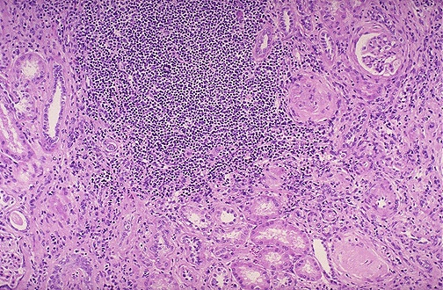
- Chronic pyelonephritis is characterized histologically by:
- Crescent formation and hyalinized glomeruli.
- Acute inflammatory cell infiltration and necrosis.
- Cystically dilated calyces and atrophic renal cortex.
- Diffuse interstitial chronic inflammatory cell infiltration.
- Invasion of the upper pole by polyhedral clear cells.

- Bacteria reach the kidney in chronic pyelonephritis through ………
- Lymphatic spread from the colon.
- Direct spread from the uterus.
- Ascending from the bladder.
- Ascending from the small intestine.
- Lymphatic spread from the liver.

- The patient with renal stone in the urinary bladder presented with…….
- Dysuria, hematuria and supra pubic pain.
- Polyurea, proteinuria and loin pain.
- Polyurea, proteinuria and generalized edema.
- Oliguria, hematuria and generalized edema.
- Oliguria, proteinuria and hypertension.

- There are ……………types of renal stones.
- Three. B. Seven. C. Five. D. Two. E. Four.
…………………………………………………………………..
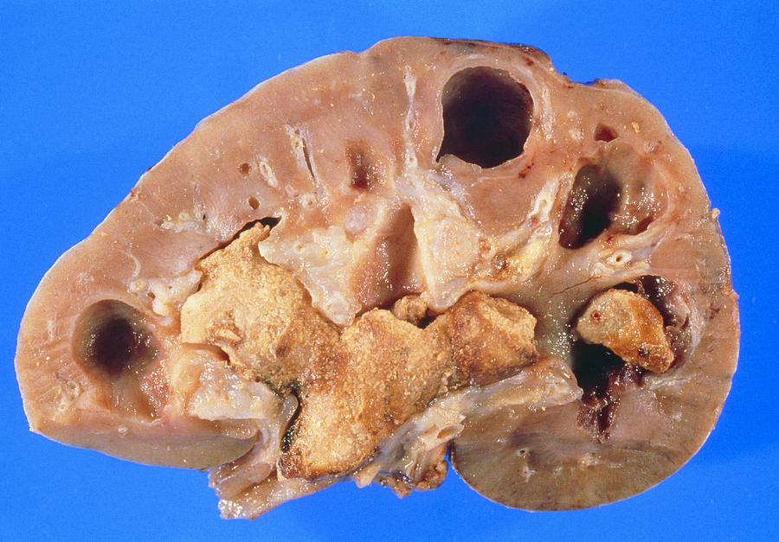
- Struvite stone is composed of………….
- Magnesium-ammonium-calcium phosphate.
- Oxalate-ammonium-calcium phosphate.
- Cysteine- magnesium-calcium phosphate.
- Magnesium-ammonium- potassium oxalate.
- Magnesium-ammonium-calcium oxalate.

- ………………….is the most common type of stones.
- Potassium. B. Calcium. C. Cysteine. D. Oxalate. E. Uric acid.
…………………………………………………………………………..
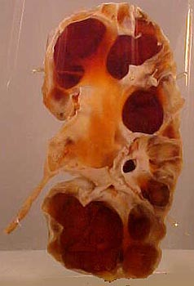
- Hydronephrosis means …………
- An enlarged kidney filled with pus.
- An enlarged kidney filled with blood.
- An enlarged kidney filled with urine.
- An enlarged kidney with a tumor.
- A congenital polycystic kidney.
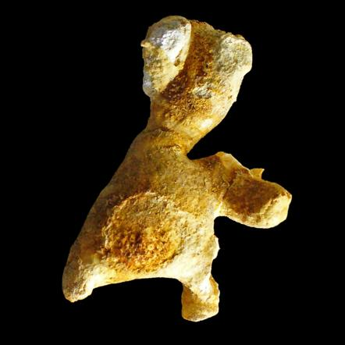
- Stag horn stone is characterized by:
- Multiple small brown in colour. D. Large, irregular surface.
- Small brown with sharp surface. E. Oval, white, smooth surface.
- Green small multiple.

- Renal cell carcinoma had all these criteria except:
- Golden yellow in colour.
- The cross section showed areas of hemorrhage and necrosis
- Occupied the upper or lower pole.
- Had well-defined margins with a fibrous capsule.
- Is called a conventional RCC.

- Renal cell carcinoma is common in:
- Males at 20-40Y. D. Females at 20-40 Y.
- Males at 40-60Y. E. Children less than 4 Y.
- Males at 10-30 Y.

- Patients with renal cell carcinoma may present with:
- Canon ball lung metastasis. D. Gross proteinuria.
- Liver metastasis. E. Acute renal failure.
- Hypertension.
………………………………………………………………………..
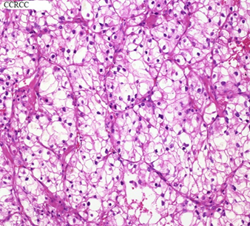
- Histopathology of conventional renal cell carcinoma is characterized by:
- Nests of polyhedral cells with clear cytoplasm and round nuclei.
- Branching papillary processes with foamy histiocytes.
- Spindle cell with marked nuclear pleomorphism and necrosis.
- Sheets of neoplastic cells with round nuclei surrounded by clear halo.
- Nests of columnar cells with deep pink cytoplasm and small nuclei.

- Wilms tumor is:
- Renal cell carcinoma. D. Chromophobe RCC.
- Nephroblastoma. E. Papillary RCC.
- Sarcomatoid RCC.
……………………………………………………………………………
II Read the following case scenario and then choose the correct answer.
- A 3-years-old child with his mother complained that she noticed a large swelling in his abdomen for 2 weeks. She recognized that the mass gradually increased in size with loss of weight and generalized weakness of her child. On physical examination the child was underweight; pale with a large soft tissue mass occupied the center of the abdomen. Sonography revealed a renal mass, 7x8cm, firm, heterogeneous in consistency. What is the diagnosis?
- Renal cell carcinoma. D. Nephroblastoma.
- Hydronephrosis. E. Renal stone.
- Chronic pyelonephritis.
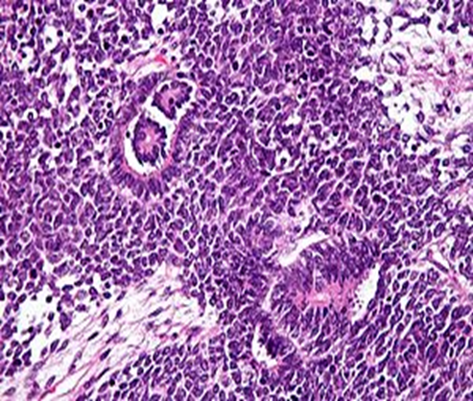
- A biopsy from the mass showed:
- Branching papillary processes with central fibrous core covered by neoplastic cells.
- Neoplastic spindle cells with hyperchromatic nuclei and eosinophilic cytoplasm arranged in bundles with frequent mitosis and necrosis.
- Blastemal cells, mesenchymal spindle cells and aborted glomeruli.
- Interstitial chronic inflammatory cell infiltration with endarteritis obliterans and renal tubular pink casts.
- Nests of polyhedral cells with round small nuclei and abundant clear cytoplasm.
………………………………………………………………………………….
- A 76-years-old obese female complained of dysuria and suprapubic pain for 2 months. She had a past history of taking anti-bilharzial drugs. Sonography showed a small urinary bladder mass 4x5cm, with necrotic areas and para-aortic LN enlargement. Transurethral resection (TUR) biopsy showed numerous glandular structures, invading the muscle wall of the bladder. What is the diagnosis?
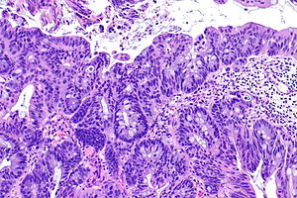
- Transitional cell carcinoma. D. Urothelial carcinoma.
- Squamous cell carcinoma. E. Adenocarcinoma.
- Bilharzial cystitis.

- What is the risk factor for this lesion in the patient?
- Old age. D. Drugs.
- Old bilharzial infestation. E. Gender (female).
- Obesity.
……………………………………………………………………….
- A 56-years-old man suffered from dysuria and hematuria for 3 months. Urine analysis showed RBCs, neutrophils and necrotic tissue. Transurethral resection (TUR) biopsy revealed cells nests and solid sheets of neoplastic epithelial cells invading the submucosa of the bladder with areas of ulceration. What is the diagnosis?
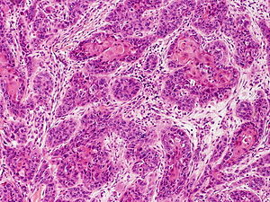
- Adenocarcinoma. D. Squamous cell carcinoma.
- Transitional cell carcinoma. E. Ulcerative cystitis.
- Bilharzial cystitis.

- What is the most serious complication of this lesion for the patient?
- Infection. D. Spread to the rectum.
- Lung metastasis. E. Spread to the urethra.
- Fistula.
………………………………………………………………….
- A 78-years-old man suffered from chronic cough and hemoptysis (blood with the sputum) for 3weeks. Clinical examination revealed a large renal mass in the upper pole of the Lt Kidney about 6x8cm, round. A biopsy from the renal mass revealed a spindle cell proliferation with manty mitosis and necrosis. What is the diagnosis?
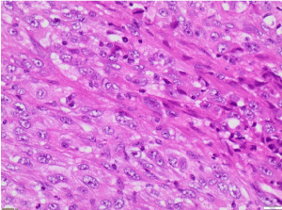
- Renal stone. D. Sarcomatoid RCC.
- Transitional cell carcinoma. E. Oncocytoma.
- Squamous cell carcinoma.

- In this patient, the lung lesion is called.
- Hearing bone. D. Stag horn.
- Canon ball. E. Cell nests.
- Brun’s nest.
………………………………………………………………….
- Match the words in the Rt column with the appropriate on the Lt column
- Thyroidization. A. Urethral stricture.
- Struvite stone. B. Minimal changes GN.
- Bilateral hydronephrosis. C. Chronic pyelonephritis
- Nephrotic syndrome. D Membranous GN.
E. Triple phosphate.
…………………………………………………………………………………
- Encircle True (T) or False (F) on each statement of the following:
- Polycystic kidney is a congenital anomaly of the kidney (T)(F).
- Bacterial infection of the renal interstitium is called glomerulonephritis (T)(F).
- Chronic suppurative pyelonephritis with marked dilatation of the renal pelvis is called pyonephrosis (T)(F).
- Marked dilatation of the renal pelvis and calyses with renal atrophy is called hydronephrosis (T)(F).
- Prostatic enlargement is a common cause of chronic glomerulonephritis (T)(F).
- Oxalate stones are primary renal stones (T)(F).
- Hypernephroma is a common cause of hematuria in old age (T)(F).
- Chronic glomerulonephritis causes enlarged kidney (T)(F).
- Hematuria, loin pain and renal mass are a triad of renal carcinoma (T)(F).
- Urothelial, squamous carcinoma and adenocarcinoma are commone types of tumors in bilharsiasis(T)(F).

